Welcome to the Spotlight section of my blog. Here I will feature things people outside of Autodesk are doing with Vault.

Today’s post is on dataLoader from coolOrange

From the creators:
dataLoader allows you to easily complete your Vaulted file properties with missing meta data, you may have from your old system or other source. A selective column and row mapping and the advanced error handling helps you dealing with small and big data source and treat non processed rows gradually.
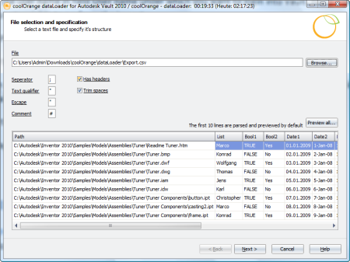
(click image for larger version)

Product URL: http://www.coolorange.net/html/products.php


About the Company:
coolOrange is a group of experienced software developers, focused on customers and users to bring coolness into their jobs. We develop products to squeeze your potential and support you to get the best out of your small and big projects.

If you want your product to be featured in my Spotlight section, send an email to doug.redmond AT autodesk.com.

